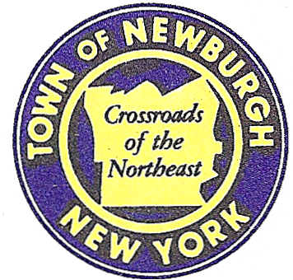

TOWN OF NEWBURGH
_______Crossroads of the Northeast __________________________
OLD TOWN HALL
308 GARDNERTOWN ROAD NEWBURGH, NEW YORK 12550

PLANNING BOARD
JOHN P. EWASUTYN, CHAIRMAN
TELEPHONE 845-564-7804
FAX 845-564-7802
E-MAIL: planningboard@townofnewburgh.org

PLANNING BOARD AGENDA

July 21st, 2016

*PLEASE NOTE: The Planning Board Meeting will start at 7:00 P.M. and all Applicants/Representatives
are to be present at that time. The Meeting will be held in the Meeting Room of Town Hall,
located at 1496 Route 300, Newburgh NY.*

1. Lands of Mann(formerly Martin) (2015-09) 2 LOT SUBDIVISION
East Road
Section 2, Block 2, Lot 22.1
Zone: RR
Rep: Heritage Land Surveying, P.C.
P.O. Box 579
Plattekill, NY 12568

2. Cumberland Farms (2016-05) SITE PLAN
270 Route 17K
Section 86, Block 1, Lot 14 & 15
Zone: IB
Rep: Bohler Engineering
17 Computer Drive West, Suite 203
Albany, NY 12205

3. Mozo Properties Site (2016-11) INITIAL APPEARANCE
NYS Route 32 SITE PLAN
Section 34, Block 2, Lot 55
Zone: B
Rep: Talcott Engineering
1 Gardnertown Road
Newburgh, NY 12550

*WORK SESSION*
Project Readiness Discussion scheduled for 5:30 p.m. in the Meeting Room of
Town Hall on Thursday, July 21st, 2016.*

PLANNING BOARD BUSINESS
WORK SESSION

July 21, 2016
5:30 P.M.

1. DLE Holdings (15-13): Landscape field review –Gerry Canfield

